Wyandotte County K-State Research and Extension

Registration Questions
913-299-9300
Jo1@ksu.edu
Kansas State University Agricultural Experiment Station and Cooperative Extension Service K-State Research and Extension is an equal opportunity provider and employer.
Important dates:

March 27 – Go! Log exercise minutes and cups of fruits/vegetables

April 3 – Registration closes

March 25, April 1,
April 29 – Order dates for Walk Kansas apparel

May 21 – Walk Kansas wraps up!

Watch for details on “Living Well” webinars to be offered on Wednesdays at 12:15 pm
To: Walk Kansas Participants

Welcome!! We are SO glad that you are “moving your way” with us again this year! Research has shown that what is good for your heart is also good for your brain. Through Walk Kansas this year, we will highlight ways that physical activity and healthy lifestyle habits improve our physical and mental health. You will also be introduced to the MIND diet so make sure you check the newsletter each week to learn more.

Join a team or go solo:
Walk Kansas is primarily a team-based program, meaning that you are part of a 6-member team that selects a goal and then supports one another during the 8-week program. You also have the option to participate “solo” if you prefer to not be on a team.

Each team will select a challenge to work toward from these options:
Challenge 1: Discover the 8 Wonders of Kansas! This journey requires each person to get 2 ½ hrs of moderate activity per week.
Challenge 2: Go Cross Country from the NE to the SE corners of Kansas, which requires 4 hrs of activity per person/week.
Challenge 3: Little Balkans to Nicodemus – a trail that takes you through SE Kansas and then up to Nicodemus with interesting stops along the way. This requires 6 hrs of activity per person/week.

During Walk Kansas, you will log minutes of moderate/vigorous activity OR total steps/day which convert to Walk Kansas miles (15 minute = 1 mile). For a complete description of activities and how steps are counted, check the Activity Guide. New this year – the system will automatically convert steps to miles.

Ready to take the first step?
Register online at www.walkkansasonline.org
If you have a team, wait for your captain to register the team online. You will receive a message by email asking you to complete registration and give your consent to participate. Your captain will be responsible for paying fees for the entire team, so make sure you reimburse your captain for your registration fee ($10).
If you don’t have a team, and would like to join one, go online and register as an “individual.” The Extension office will connect you with a team that has similar goals. If you prefer to go solo (not be on a team) select the “solo” option when you register.

March 27 – May 21 2022
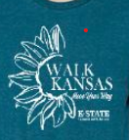
Walk Kansas t-shirts and other apparel:
Show your Walk Kansas pride by wearing a t-shirt or sweatshirt! After completing registration, log into the portal with your username and password. Click on the “shop” button on the purple bar at the top. This will take you to our apparel vendor site, www.shopwalkkansas.com and you can place your order. The website will calculate shipping and tax, and the items will be shipped directly to you. Please note the dates for placing orders.

Healthy Eating for Mind and Body
It’s no secret that following a balanced diet provides immense benefits for overall health, but did you know that eating a certain way can help protect brain function and reduce your risk of developing dementia and Alzheimer’s disease? Fruits and vegetables play a key role in the MIND diet, so we ask you to log cups of fruits/veggies again this year. You will learn more about the MIND diet through weekly newsletters and webinars. Tasty recipes will be shared as well!

Report/Log online – begin March 27:
Once your team is “ready” (all members have an account and have paid) you will see this “Dashboard” where you log minutes, etc., and chat with your team. This will be available on March 27, not before. Along the top horizontal purple bar: Click on “Events” to see what is happening in your community, learn about Walk Kansas webinars and the Walk Kansas 5K/Fun Walk; “Resources” is where you will find program newsletters and other information; “Shop” is where you can purchase apparel.
On the bottom purple bar -- See your welcome message, team name, and group (county). After you enter your activity minutes or daily steps (the system automatically converts your minutes and steps into miles), click on the “See Your Map” icon to find a map of Kansas with your challenge trail displayed. Here you will unlock points of interest on the trail and learn more about our great state. Click “Team Chat” to communicate with team members and check just under the purple bar for posts from your chat group. “My Team” shows all of your team mates and “Log History” shows what you have logged for activity, f/v, etc. Earn badges along the way for activity, logging, reading, and more!!

To log your progress: In the purple box, log your minutes/steps of activity – the system will calculate into miles. (Read the Activity Guide to know what counts); the red box displays the total miles your team was walked and this also takes you to the “team chat” page; record cups of fruits/veggies in the yellow box. If you do strengthening exercises that day, click “log” in the blue box; the green box is where you can log the number of 8 oz. glasses of water you drink (optional).
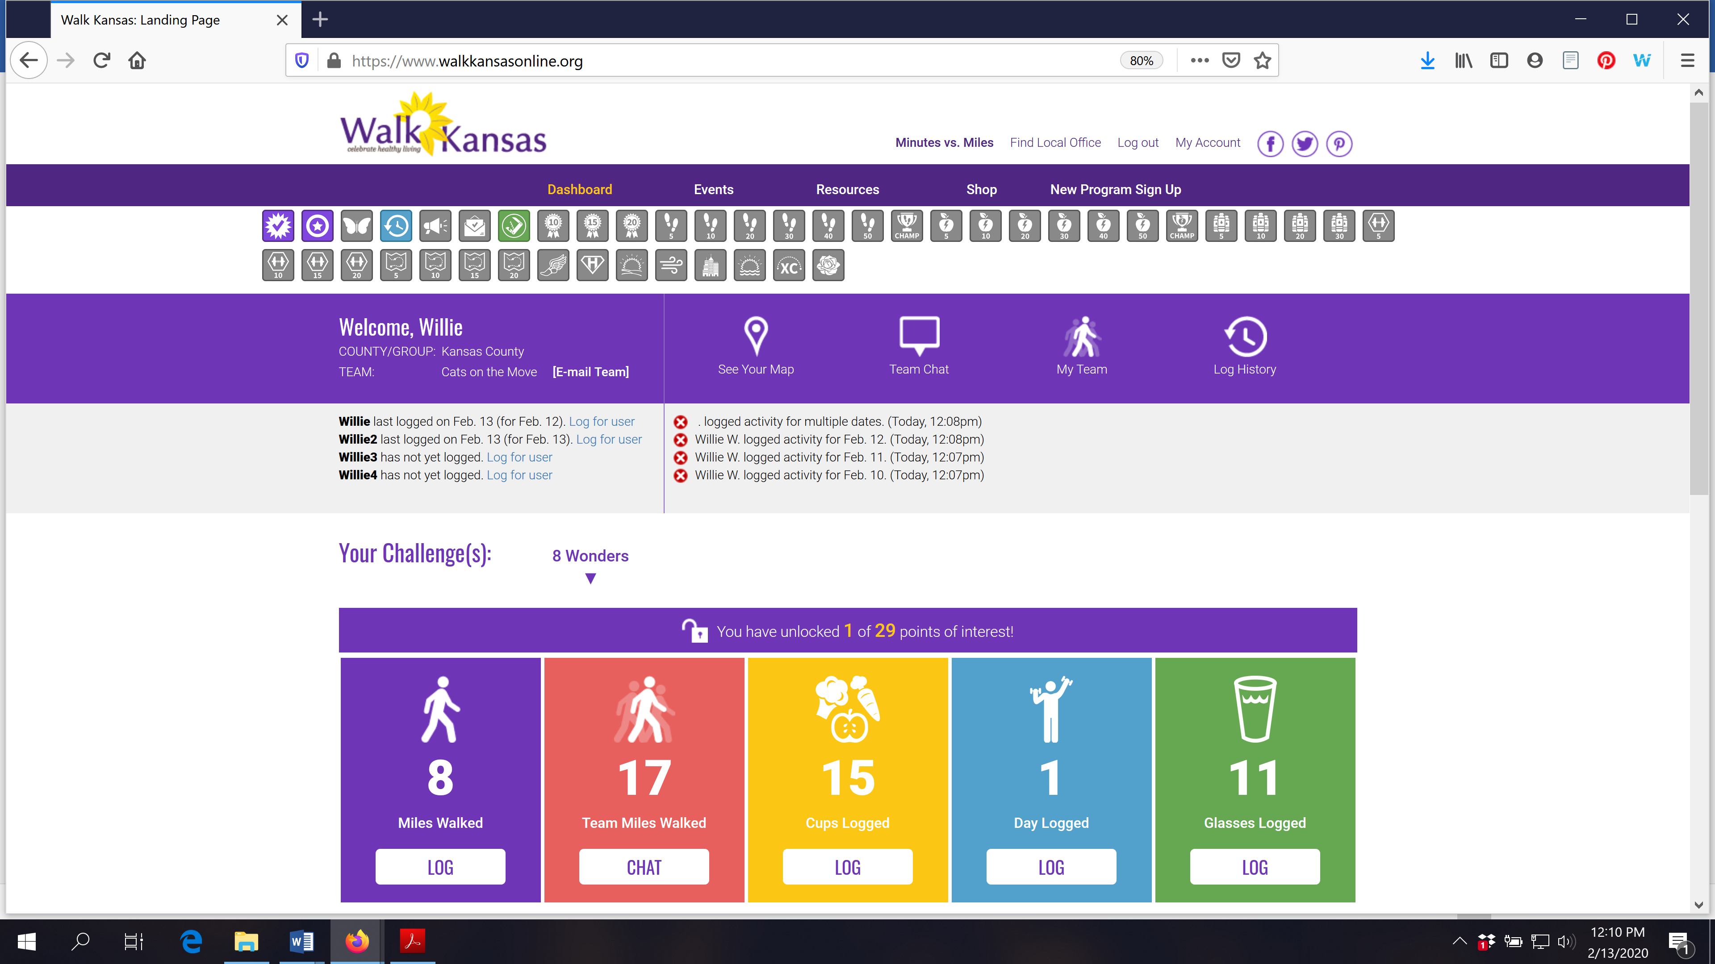

If you scroll down the page, you will see a white “Leaderboard” box. This is where other teams from your community will appear along with their progress. You can also stay connected with other participants through our Facebook page. Like Kansas State University Walk Kansas on Facebook.
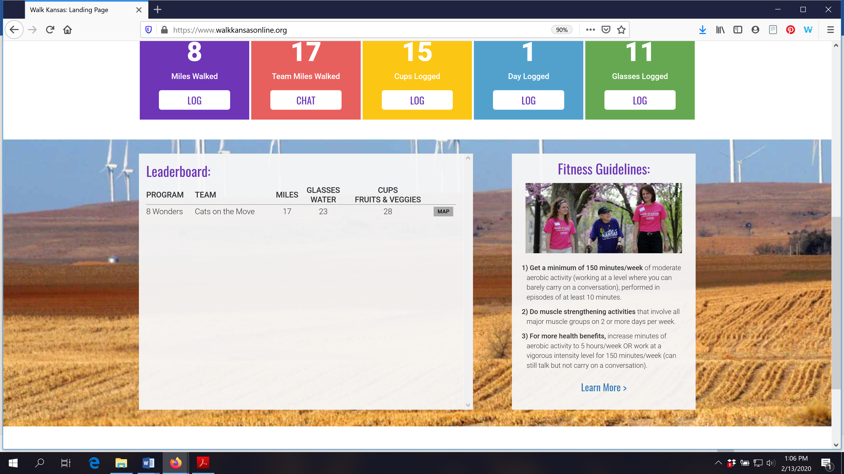

You can see how all teams in your community and across Kansas are doing by going to the “Leaderboard” located on the login page, www.walkkansasonline.org. Click on the blue Leaderboard box at the bottom of this screen.
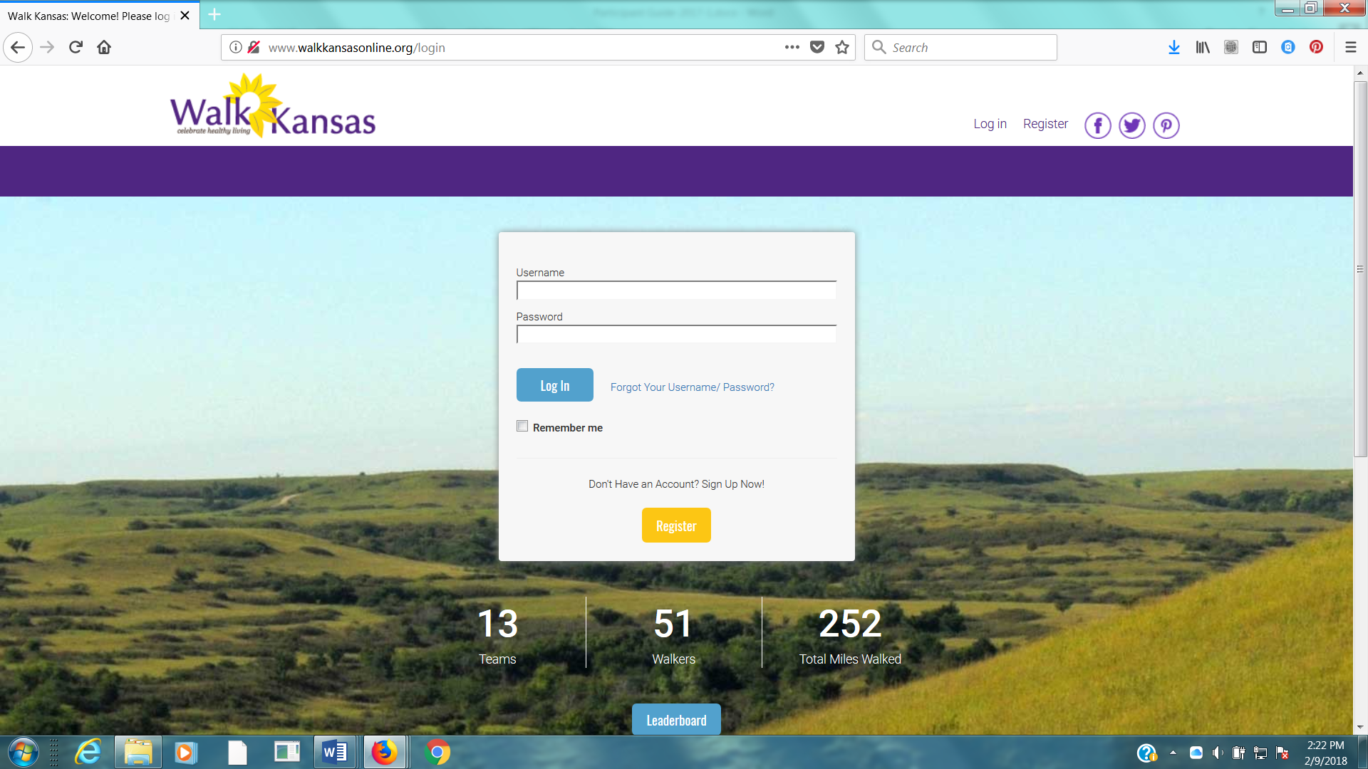

We have an app!
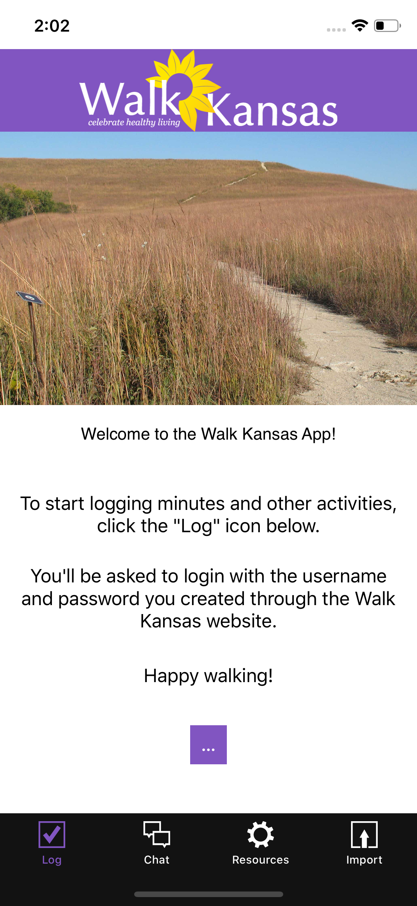
The Walk Kansas app is free and you can download it from the App Store. The app is available in iOS format for iPhone and iPad AND Android this year!!!
You cannot register through the app so wait until your account is set up online first. Then, you can access all of your information and log minutes, etc.
The Walk Kansas app will sync with fitness trackers. However, if you have a Fitbit you will need to download Fitbit to Apple Health Sync ($5.99) for this data transfer.

Using the Walk Kansas app:
- Before you use the app make sure your team is created online, that you have selected a challenge (from the 3 available), and make sure that logging is ready to go and that your team is ready. You may want to test this online first to make sure you can log minutes.
- When you open the app for the first time, you’ll see a splash screen that tells you to login with the username and password you created on the WK website. When you close this screen you will see some login fields.
- After you login, the default screen should be the log activity screen; click “new log” and have at it!
- To edit an existing log just click the row you want to edit.
- All data entered through the app will transfer to the web and vice versa.

